Creating multiple resources
Creating multiple EC2

VPC and subnet creation
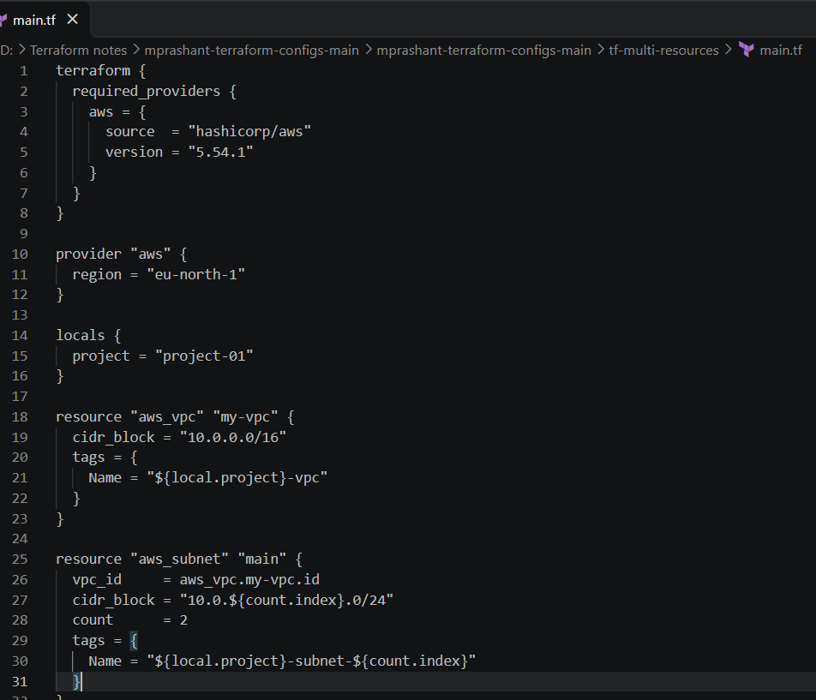

EC2 creation
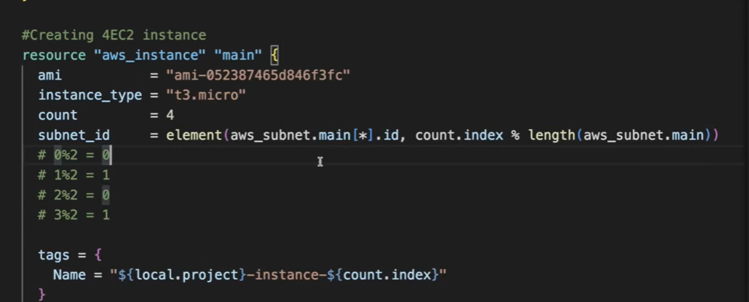
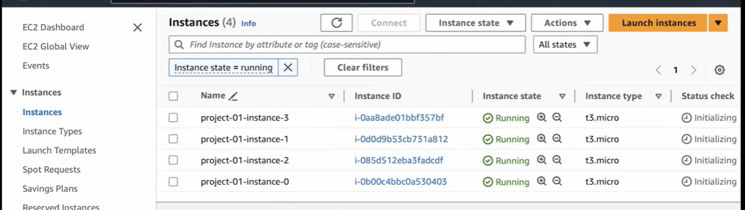

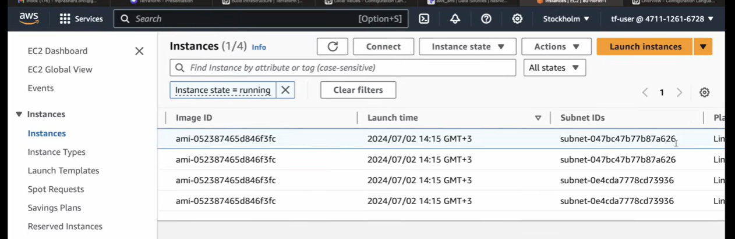
Same type of ami and instances.

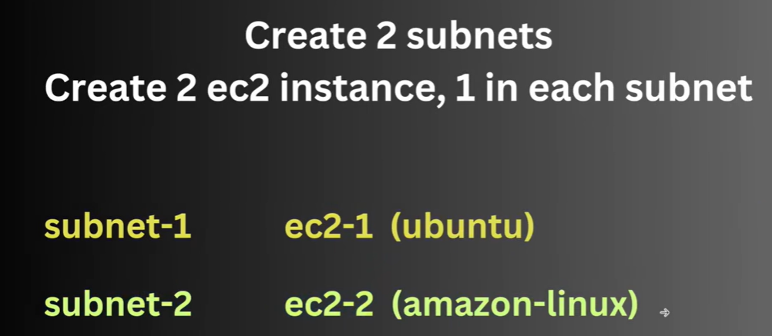
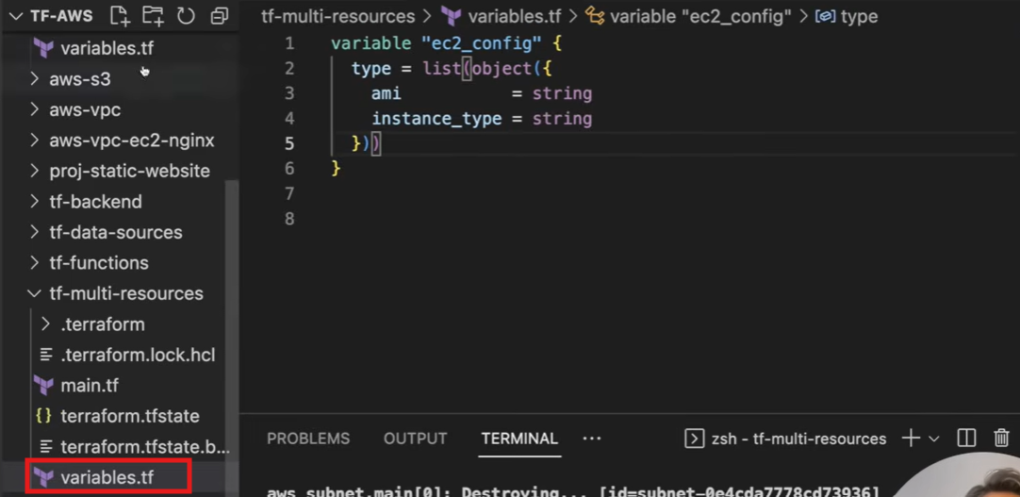
Created variables
========================terraform.tfvars====================
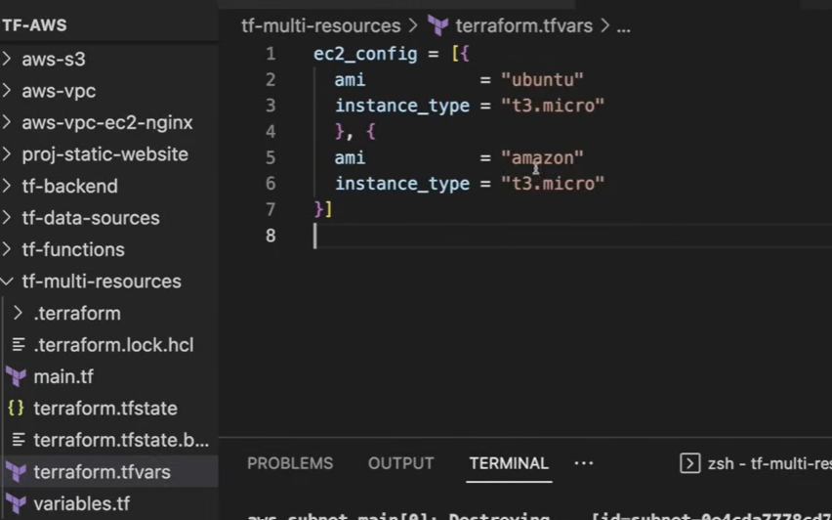
Taking the value from ec2 instances
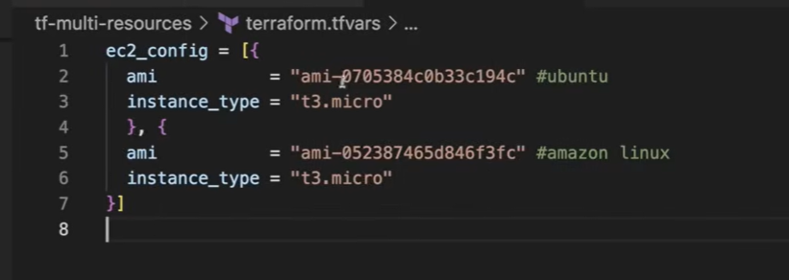

Main.tf
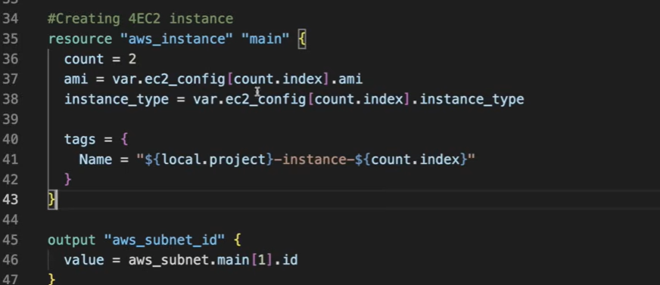
1st time it will run and take 1st value from terraform.tfvars and in 2nd run it will take 2nd value.

We can use the dynamic value of count
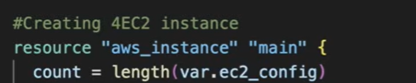

Adding the subnet
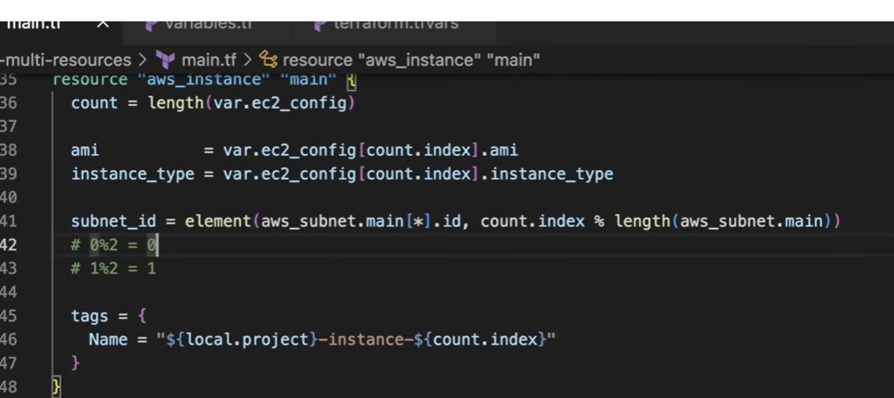
Apply
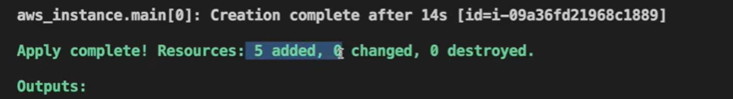
1 vpc, 2 subnet and 2 EC2 instance
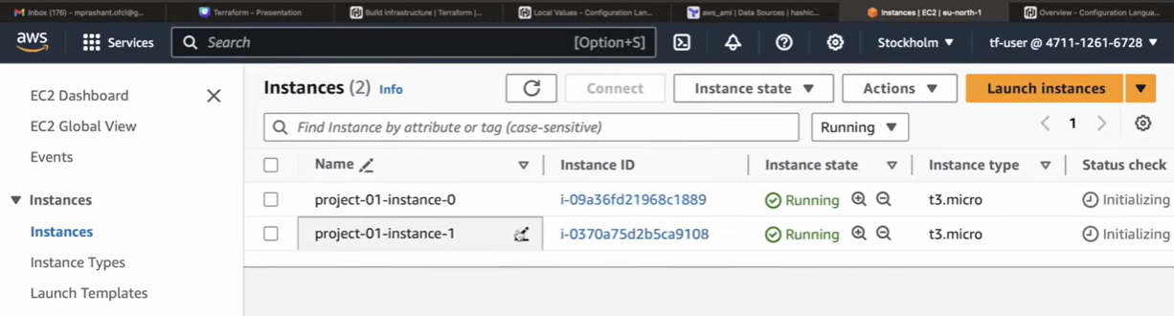

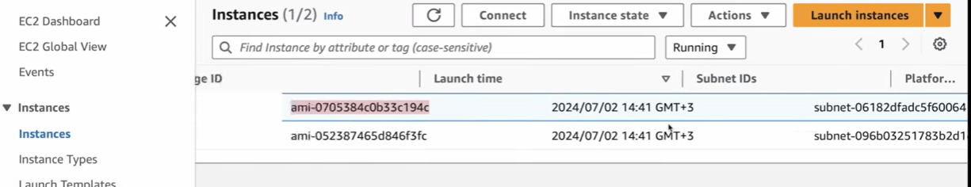
Images of 2 different OP system

We can check the both instances of different OS
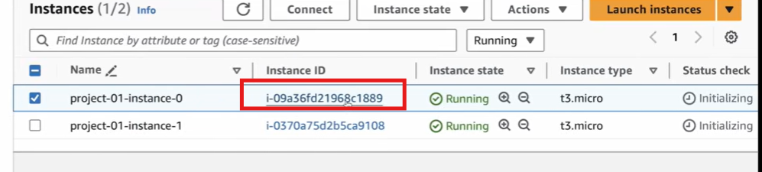
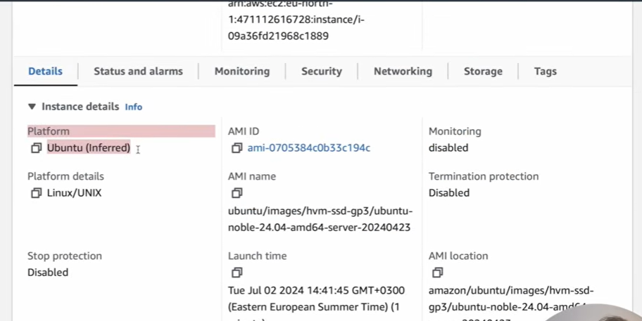
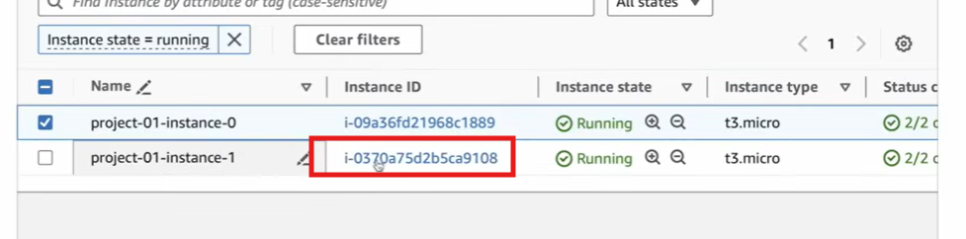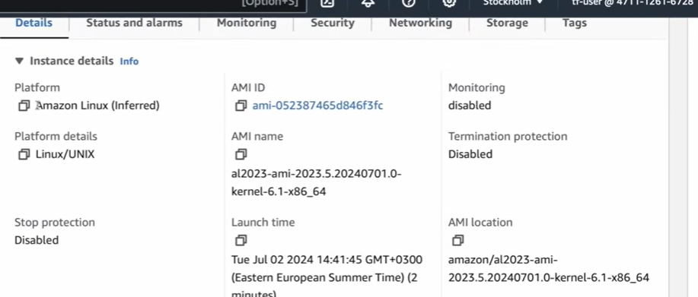

Subnet id
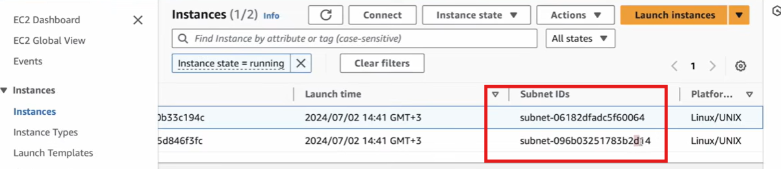

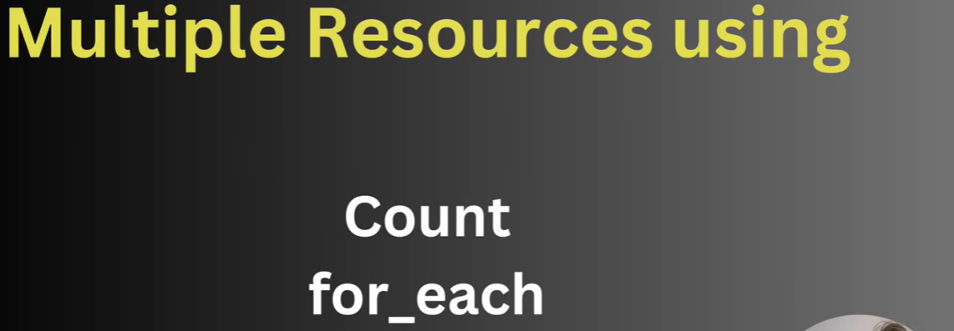
For each is used with map or set
Map means we are providing in the key value pair.

Map file
terraform.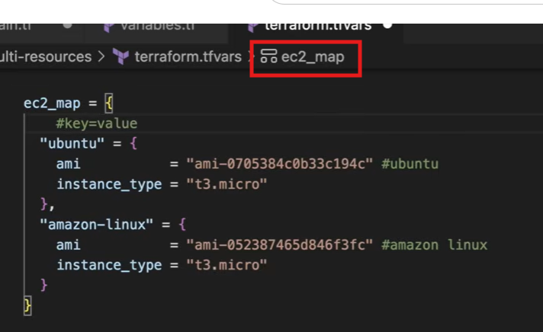
ubuntu(key): ami,instance_type(value)
terraform.tfvars
